

The Gardening Robot

Assembly Manual  
Joseph El-Nouni  
Final Project II

Contents

Abstract 3

Introduction 4

Understanding V-G.O.R. 5

Unit and Features 5

High Level Overview 6

Hardware Design 7

Software Design 8

Preparation 10

I. Gathering Components 10

II. Designing the Daughter Board 14

III. Specifications & Testing 14

Assembly 15

I. Pre-assembly 15

II. The Hardware 15

III. The Firmware 15

IV. The Interface 15

Operation 16

I. Powering On 16

II. Pairing 16

III. The Front Panel 16

Closing 17

Annex A 18

Annex B 19

Figures

Figure 1: High-Level Overview 7

Figure 2: Hardware Block Diagram 8

Figure 3: Firmware Block Diagram 9

Figure 4: GUI Block Diagram 10

Figure 5: STM Nucleo 11

Figure 6: HC-06 Bluetooth Module 11

Figure 7: HC-SR04 Ultrasonic Sensor 11

Figure 8: TCS3200 Color Sensor 12

Figure 9: CCTV Battery 12

Figure 10: DC Water Pump 12

Figure 11: Low RPM Motor 12

Figure 12: High RPM Motor 12

Figure 13: TS101 Shock Absorbing Chassis 14

Figure 14: GUI Front Panel 17

Tables

Table 1: Bill of Materials 13

# Abstract

# Introduction

As the modern age progresses, work schedules are becoming more and more busy. For many hobbyists, this is a curse, as they can no longer partake in their pass-times at their leisure. This is especially true for gardeners, as the efforts taken to maintain a crop must remain consistent for there to be any yield. Thus, the idea of a robot gardening assistant has become a very convincing prospect, with many successful projects having come out of that in recent years.

V-G.O.R., the Vegetable Garden Observing Robot, aims to solve this issue by offering exactly what the hobbyists envisioned, but without the heaviness or price tags attached to other similar works. The project consists in the construction of the V-G.O.R. unit, an automaton designed to care for a vegetable garden by means of plant detection, watering, weed detection, weed removal, etc. Built for intractability, the robot’s Bluetooth connectivity allows a user to control and monitor it from a distance. Finally, while the user is out on a busy day, V-G.O.R. is able to sustain its activities for hours at time, making it a valuable addition to any vegetable garden.

# Understanding V-G.O.R.

## Unit and Features

As previously mentioned, the V-G.O.R. robotic unit is an autonomous wheeled vehicle capable of sensing its surroundings through various means, identifying the various objects within the vegetable garden it is stationed in and reacting in accordance. Its primary goal is to ease the work of gardeners by taking care of the menial and repetitive tasks of watering, weeding, and planting seeds. Following this premise, the unit:

* Can move in all 4 directions;
* Can navigate rough terrain;
* Can sense nearby objects, as well as their distance;
* Can avoid objects as it moves;
* Can differentiate plants and weeds;
* Can water plants;
* Can cut out weeds;
* Can place seeds and bury them;
* Can operate autonomously;
* Can be operated using Bluetooth;
* Can send data to an application via Bluetooth;

## High Level Overview

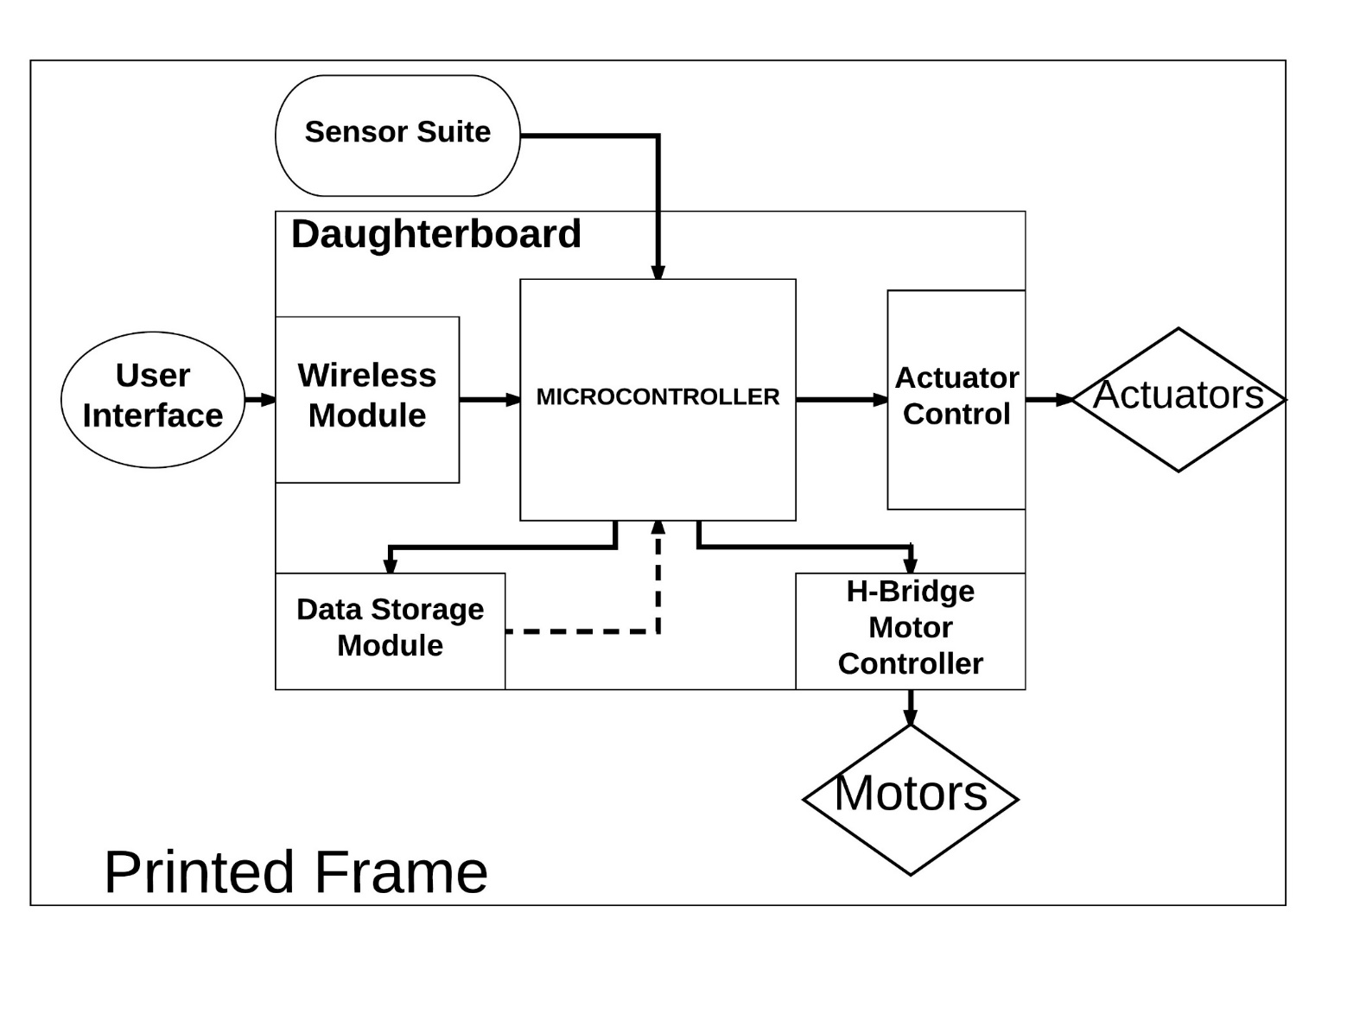The following section presents the thought process that went behind the design of the V-G.O.R. Project.

Figure 1: High-Level Overview

The following figure offers a high-level overview of the entirety of the unit

In a typical scenario, the Microcontroller, which is basically the brain board of the circuit, manages the autonomous routine to be followed during the unit’s lifecycle. In that time, the unit will be moving about, gathering data using its sensors. After that data is interpreted by the Microcontroller, it will send commands to the motors or the actuators in response to the current situation. It will simultaneously store data over time for later review. Finally, the routine may be interrupted at any time by an input from the user on the Graphical User Interface, GUI, which will communicate to V-G.O.R., interrupting any current actions.

## Hardware Design

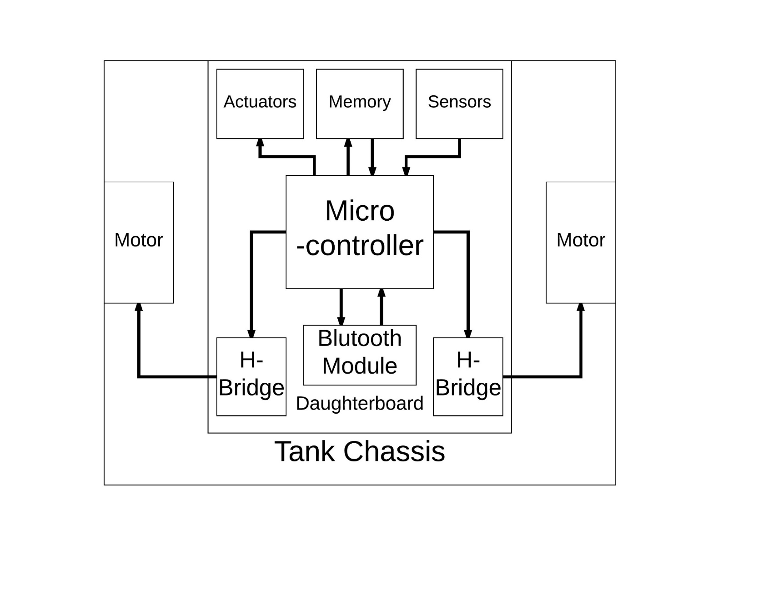This next figure focuses on the hardware components.

Figure 2: Hardware Block Diagram

The important things to take note of, that have not been previously mentioned, are the locations of the various components. Here, it is clear that all components except for the motors themselves will be located on the daughterboard, which will then be placed on the chassis, the vehicle’s shell.

## Software Design

The software for this project is comprised of two distinct pieces. The various functions included within this software are split between these pieces. The first section, the Graphical User Interface, will be a mobile application. It will take inputs from the user, translate them, and send them wirelessly to the microcontroller. The microcontroller will evaluate what the commands are and operate the V-G.O.R.’s motorized frame (and its actuators) accordingly, using sensor data to orient itself. It will then take the data it has personally collected and send it back to the GUI for monitoring.

The first section, called Firmware, is the software portion located on the microcontroller, in charge of operating the unit. The general design for it is outlined in the following:

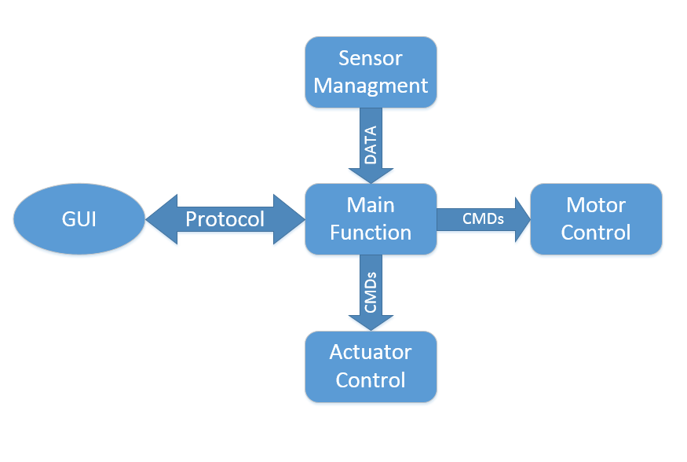

Figure 3: Firmware Block Diagram

It is important for the firmware to be programmed with a communication protocol, between it and the User Interface, kept in mind. One should also take note to create separate functions that can be called multiple times for both the motor controls and actuator controls, as throughout a regular routine, they will be called on countless times.

As for the Graphical User Interface, its high-level overview is outlined in Figure 4.

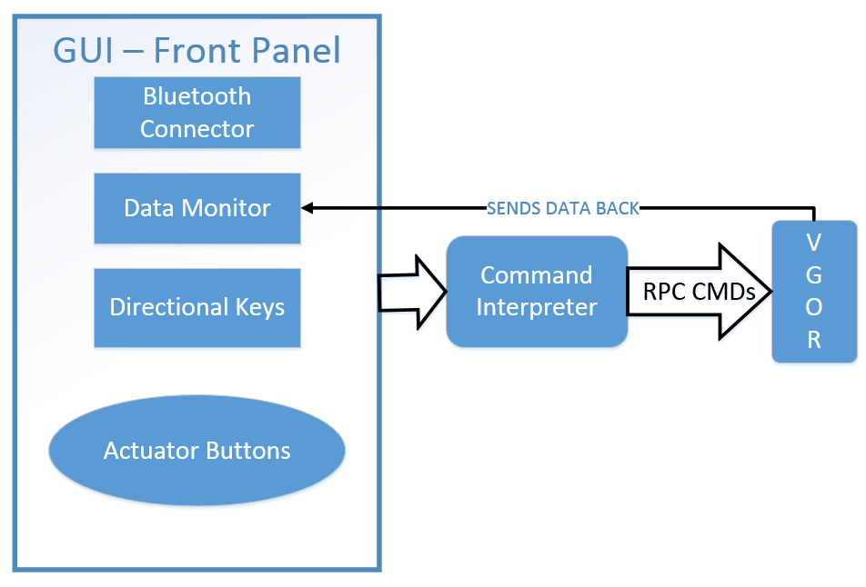

Figure 4: GUI Block Diagram

The front panel displays the various options that a user can take. From there, whichever option is chosen will be translated according to the aforementioned communication protocol established and then sent over to the unit itself. What’s more, any data received back from the unit is to be displayed on the status monitor.

# Preparation

## Gathering Components

1. 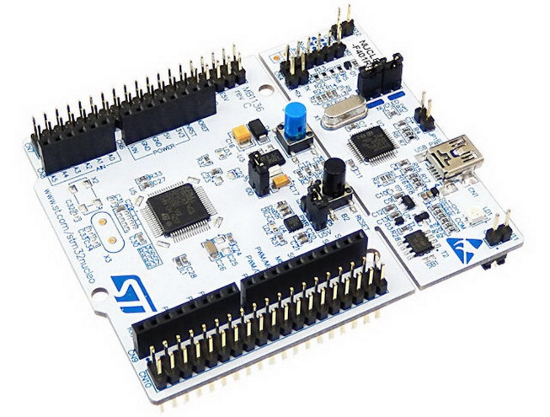Microcontroller  
   The Microcontroller Board used in this project is the STM32F411-RE, otherwise referred to as STM Nucleo. It possesses many (up to 47) I/O’s, a necessary feature for this project. Secondly, it has a very high, 100MHz processing speed which makes it very advantageous, as the robot will require a multitude of quick scans, making it harder to move seamlessly. Thirdly, it is supported by the popular mbed programming platform. Finally, it also has a small price, making it more accessible despite being on the middle-high end, in terms of power.

Figure 5: STM Nucleo

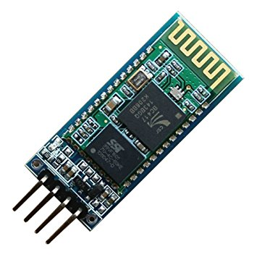

Figure 6: HC-06 Bluetooth Module

1. Bluetooth Module:

The module used for this project is the HC-06 Serial Bluetooth Module. As its name suggests, it provide a Serial Bluetooth connection at a distance of up to 10 meters, meaning that it behaves exactly like a serial (USB) cable, but over a wireless connection. This makes communications very easy to configure for the V-G.O.R. Prototype.

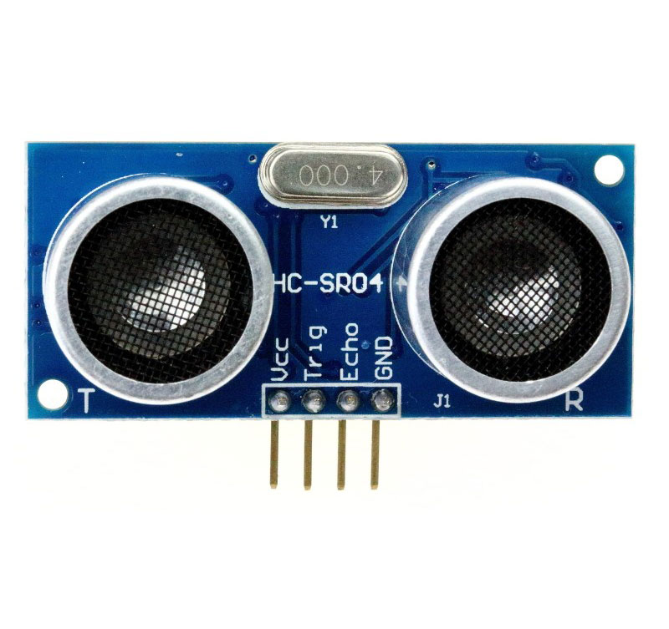

1. Sensors:

There are 2 main sensors being used in this project. The first, used to sense distance, is the HC-SR04 Ultrasonic Sensor, which uses ultrasound waves to sense its distance from the nearest object. It does this by capturing the waves reflected from that object and calculating the distance based on the time it took to re-capture the ultrasound.

Figure 7: HC-SR04 Ultrasonic Sensor

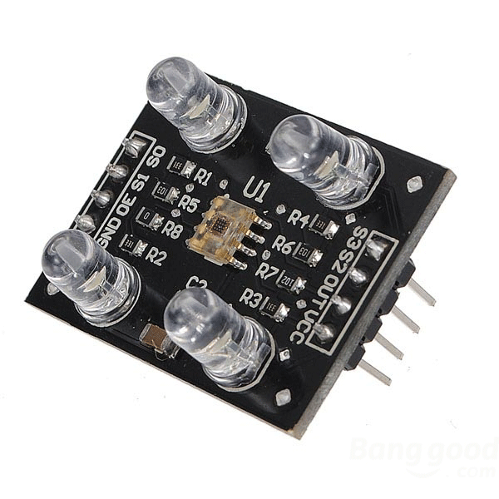The second sensor, used to detect color, is the TCS3200 RGB Photodiode sensor. Four inputs control which color is sensed, and a wavelength value is generated for each of the RGB colors as the inputs change. The values vary for the different colors (which have different wave properties), but each possesses a minimum and maximum value. These two extremities can be translated to form a slope between 0 and 255, allowing the sensor to produce RGB values.

Figure 8: TCS3200 Color Sensor

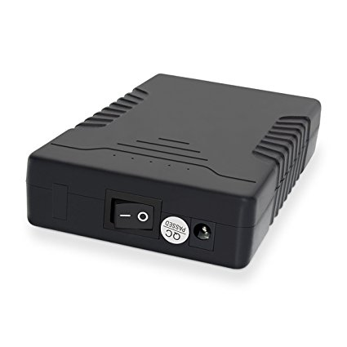

1. Other Materials:

There are a few other components which require special attention.

Firstly, the battery used in this lab is a 12v, 3000mA/h battery, normally found in a CCTV Camera. It can be connected to the PCB when plugged in conjunction with a female-to-terminal header adapter.

Figure 9: CCTV Battery

Next, the three actuators are all made up of DC Motors:

* The water pump, in charge of watering, is a DC 12V aquarium pump (Figure 10);
* The weed whacker is made up of a 6V DC very high RPM Motor (Figure 11);
* The wheel which deposits seeds will be spun with a 6V very low RPM Motor (Figure 12).

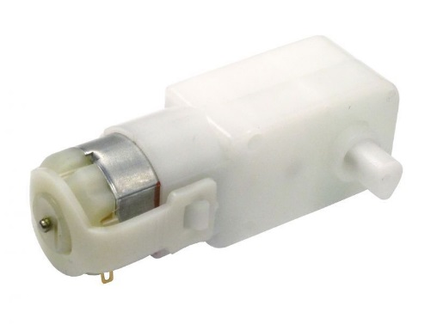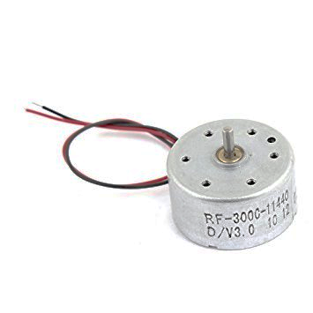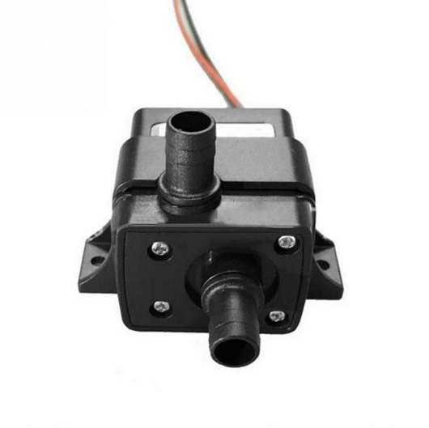

Figure 10: DC Water Pump

Figure 11: Low RPM Motor

Figure 12: High RPM Motor

Moving along, it’s important to have the following materials at hand to continue the assembly:

* Hardboard;
* Screws, washers and nuts;
* 4+ inch length Hex PCB Standoff Screws;
* Adhesives: Glue, tape, etc.

1. Discrete Components:

Excluding the previously mentioned components, all that is left are the components needed to populate the PCB.

These components are outlined in the following Bill of Materials:

Table 1: Bill of Materials

|  |  |  |
| --- | --- | --- |
| **ITEM TYPE** | **QTY** | **Details/Values** |
| SD Storage Breakout Board | 1 |  |
|  |  |  |
| L298N Dual H-Bridge | 1 | 12V, 2A |
| 74LS151 | 1 | 8 to 1 MUX |
| Voltage Regulator | 2 | 3V3 Output |
| 2 | 5V Output |
| 2 | 6V Output |
| Diode | 5 | 50V, 1A |
| 10 | 1kV, 1A |
| Resistor | 5 | 10K |
| Capacitor | 4 | 220uF |
| MOSFETS | 5 | 20V, 3.5A |
| Terminal Block | 6 | 2 Positions |
| Female Headers | 4 | 19 Positions, single row |
| 1 | 16 Positions, two rows |
| 2 | 4 Positions, single row |
| Power Switch | 1 | 1kV, 6A |
| Male headers | 5 | 4 positions, single row. |
| 1 | 8 positions, two rows, right angle |

1. Chassis:

The chassis for this project is the TS101 Shock Absorber Tank Chassis.

This Chassis was chosen because of its adaptability to various terrain, as well as its ability to support high amounts of weight. It also came packaged with two motors that contained encoders, making it more attractive as a deal.

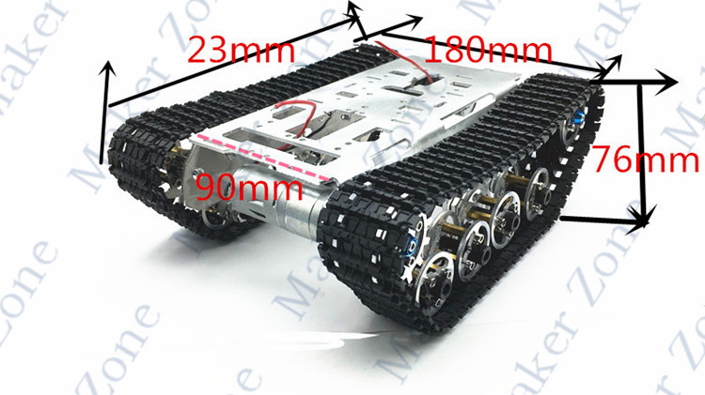

Figure 13: TS101 Shock Absorbing Chassis

## Designing the Daughter Board

## Specifications & Testing

# Assembly

## Pre-assembly

There are a few things one should confirm before moving beyond this point:

* Components have all been tested to avoid any faults;
* The Daughterboard has been checked for circuit design/printing errors;
* The Daughterboard has been soldered together;
* Power has been tested on the daughterboard to ascertain that it has been assembled correctly and that the right parts have been placed in the right packages.

## The Hardware

1. Gather all needed materials, making sure pre-assembly has been completed.
2. Screw the hex spacers into the chassis, in the locations specially drilled for on the PCB.
3. Place the battery in between the hex spacers directly on the chassis surface. Use restrainer/adhesive, to make sure that it doesn’t move.
4. Fix the battery charging point right next to the battery itself, on the backside of the chassis.
5. Screw the PCB onto the spacers.
6. Place the STM Nucleo into the Female Headers.
7. Plug in external components ONE AT A TIME, making sure to TEST EVERY ADDITION. This is to ensure that any errors encountered can be most easily fixed with any damage done to the unit.
8. Once every component has been plugged in and has gone through rudimentary tests, the V-G.O.R. is ready to receive firmware.

## The Firmware

## The Interface

# Operation

## Powering On

To power on the V-G.O.R., simply turn on the Battery, followed by the Daughterboard’s power switch.  
You’ll notice the lights on the Nucleo beginning to flash. If both lights are on, that means that the Nucleo has been powered successfully.

## Pairing

Once power is ON, the Bluetooth module will have a blinking LED as well. The LED will be blinking very fast prior to pairing.

In order to pair, simply turn on your cellphone’s Bluetooth and head into the VGOR_APP. Once there, click “Choose Device”, and select HC-06 from the menu. Click “connect”. Once the screen displays the message “Connected!”, the device has been paired. This can be confirmed by the LED on the module, which will stop blinking.

## The Front Panel

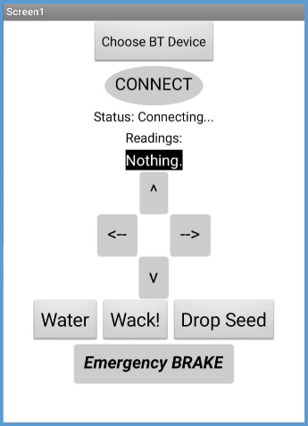

The Front panel contains 10 buttons:

1. Choose BT Device: Chooses which device to pair with;

Figure 14: GUI Front Panel

1. Connect: Establishes connection with selected device;
2. UP: Moves unit forward;
3. Left: Moves unit left;
4. Right: Moves unit right;
5. Back: Moves unit back;
6. Water: Activates water pump;
7. Wack! Activates weed whacker;
8. Drop Seed: Activates seed wheel;
9. Emergency Brake: Stops the vehicle no matter what.

# Closing

# Annex A

***Important Terms***

# Annex B

*Part Specifications*